ARTIFICIAL INTELLIGENCE

LAB PROGRAMS

**Aim:** The goal of this Python script is to solve the 8-puzzle problem using Breadth-First Search (BFS). 8-puzzle is a sliding puzzle consisting of a 3×3 grid with 8 numbered tiles and one empty space (represented here by 0).

**Algorithm**

1. Start with the initial state.
2. Put it in a queue.
3. Remove the front of the queue → expand possible moves.
4. If goal found → stop.
5. Else → add new states to the queue.
6. Repeat until solved

CODE:

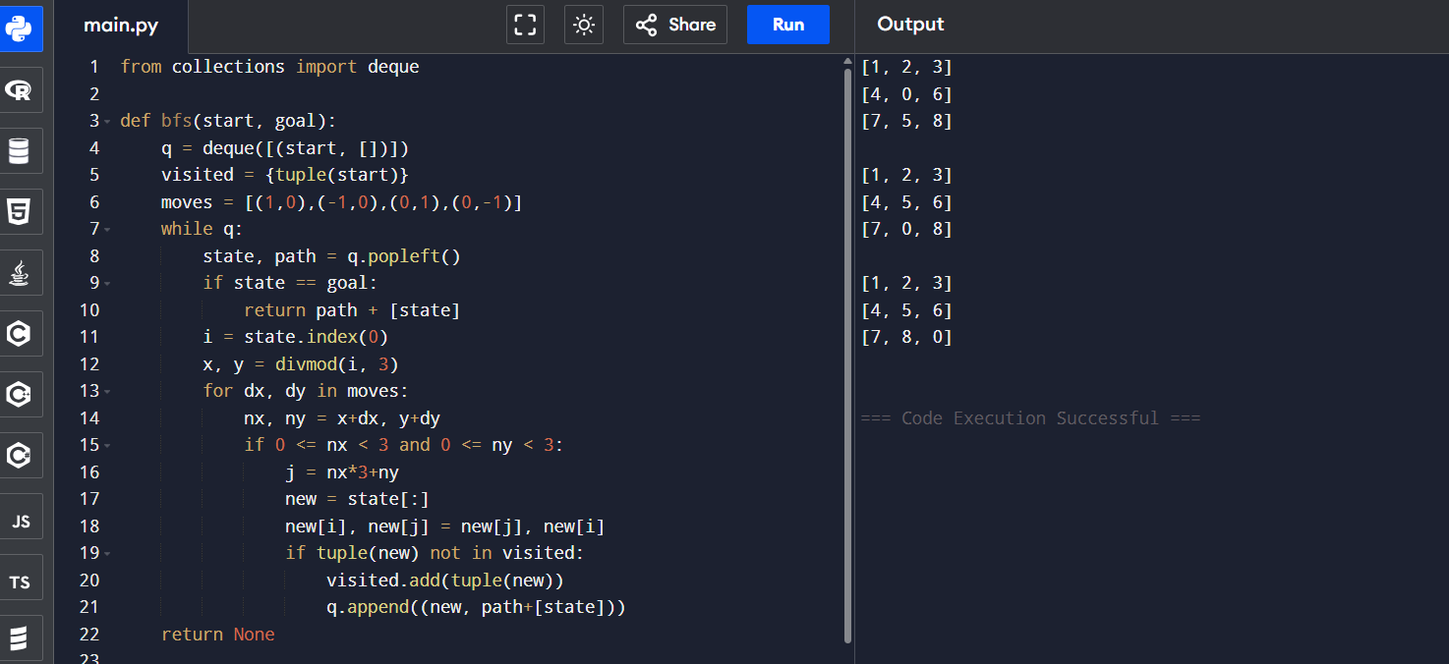

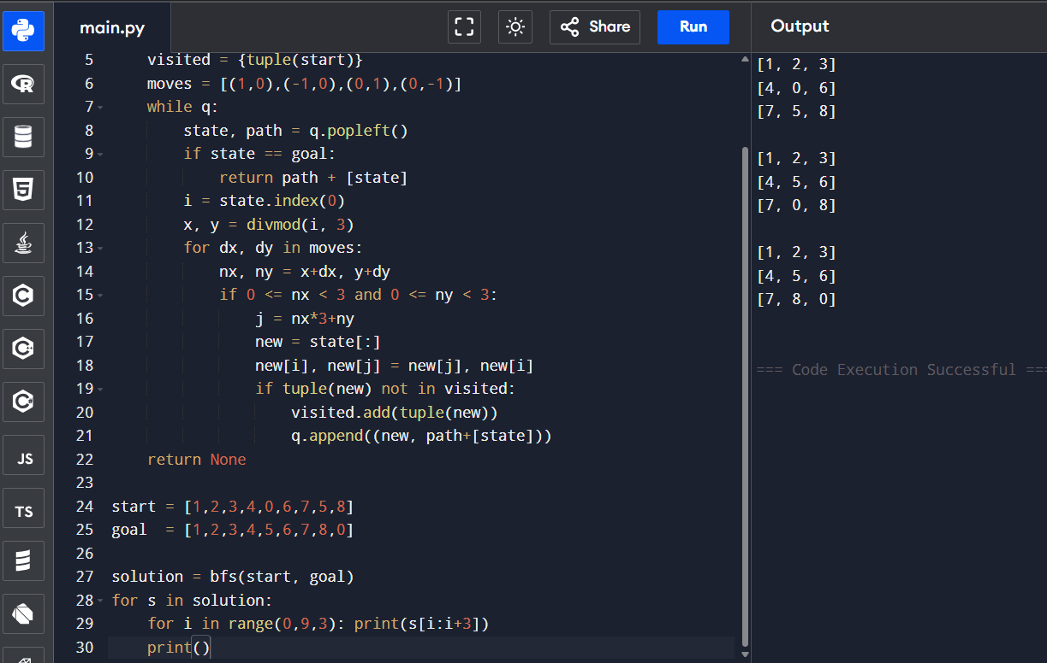

**RESULT :**

The 8-Puzzle problem is solved in 2 steps, reaching the goal state.